Given the root of a binary search tree, return *a* ***balanced*** *binary search tree with the same node values*. If there is more than one answer, return **any of them**.

A binary search tree is **balanced** if the depth of the two subtrees of every node never differs by more than 1.

**Example 1:**

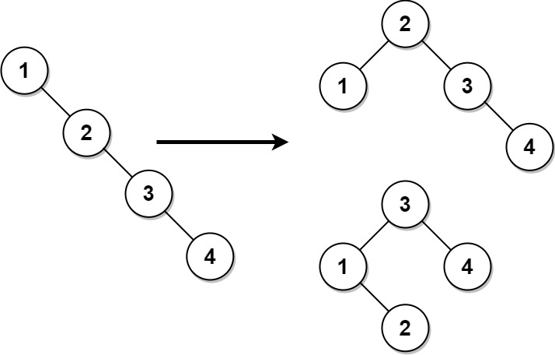

Input: root = [1,null,2,null,3,null,4,null,null]  
Output: [2,1,3,null,null,null,4]  
Explanation: This is not the only correct answer, [3,1,4,null,2] is also correct.

**Example 2:**

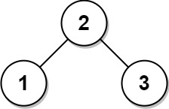

Input: root = [2,1,3]  
Output: [2,1,3]

**Constraints:**

* The number of nodes in the tree is in the range [1, 104].
* 1 <= Node.val <= 105